Design Aesthetics of Mobile Interface
Shafiq ur Rehman, Jane-Lisa Coughlan

Abstract—Mobiles are considered to be the most frequently used electronic items in world after electricity. It is probably the only device that can be used by any gender with no age limits depending on its functionality. This paper present the interactive interface of Mobile and particularly aiming the use of advanced phones which are also called smart phones. With the changes in the trend where users are now moving from ordinary mobiles to the one with touch screens and facilities such as WiFi and internet browsing.
International Science Index, Humanities and Social Sciences Vol:6, No:5, 2012 waset.org/Publication/12340

Keywords—interface design, functionality, intelligent system

- INTRODUCTION
D
UE to high demands by the users, the mobile companies are trying to produce new mobiles with different features
and looks almost every week. This has made the mobile market very competitive. A user prefers a mobile with good and useful application, better design and mostly the ease of use. Mobile manufacturing companies and its application developers are constantly working on making their product user friendly. Unfortunately still many high end mobiles failed to provide what users intend to get. When it comes to utilities and functionalities, most of the advanced mobiles do provide them but what is of most importance here is how easily user can learn and use the provided features.
For this report I have particularly studied one of the latest mobiles called HTC HD7. The mobile has almost every facility that a common mobile can provide. Besides it provides a large screen of 4.2” in comparison to Iphone’s 3.8”. This big screen on one hand is useful in reading text or more enjoyable to see pictures or watch movies but on the other hand often people find it over sized and uncomfortable for carrying in their pockets.

A. Problem Identification
During the use of the HTC HD7, several major issues were identified which adversely affect the performance of the overall use of mobile. The focus was on discussing the problems that would not only be faced for novice users but to those who even uses the mobile for more than few months. Besides these problems are generic and can be deduced for other mobiles systems as well.

Following are some of the issues identified during survey on the mobile design.

Shafiq Rehman is an Assistant Professor at Department of Computer Science, National University of Computer & Emerging Sciences, Sector H- 11/4, Islamabad, Pakistan (e-mail: shafiq.rehman@nu.edu.pk).
Dr Jane Coughlan is a Lecturer in the School of Information Systems, Computing and Mathematics at Brunel University London, Uxbridge, UB8 3PH, United Kingdom (e-mail: jane-lisa.coughlan@brunel.ac.uk).
- A touch screen with very good sensitivity is provides comfort and ease in use but when the sensitivity moves to very high almost extreme above certain level, it becomes annoying to the users. One issue with the current HTC HD7 is its very high sensitivity which leads to several unintentional human actions performance.
- Another issue discussed and discovered was whether using three menu buttons rather than a single, is a good idea or is it not at all.
- When it comes to buttons, some people prefer to have a solid button so they may feel a proper feedback but often mobiles have soft or touch buttons. The issue whether to use a touch button or a solid button is also discussed in this paper.
- Designing appropriate buttons with very common shapes that even an ordinary mobile user can easily recognize a button for use. The button should have a proper shape and a boundary defined inside which it can perform task, any other area surrounding the button, when touched should not perform the action. This is a major issue and design flaw in HTC HD7.
- Though making a mobile slim is a good idea and most of the time very convenient as it has reduced weight and can easily be placed in pockets for being less specious but when mobiles are made very slim, they are hard to hold and use. This is another issue with under study mobile model.
- Smart phones provide intelligent system of slipping the screen vertically or horizontally depending on the users action and in which way the user feels comfortable while holding the mobile. Sometimes this auto screen flipping becomes annoying. This issue was also seen and discussed.
- Most of the smart phones provide a menu with scrolling. It is very convenient when the list is too small. There is indeed a need for an interface where we can get rid of too much scrolling and can access an application just in few clicks as clicking is a lot faster than scrolling in mobile phones. This issue has been seen and discussed as well.
- Vibration or force feedback is important for both visually impaired people and those who mostly work on their mobiles in silent mode. There is a need for defining different vibration modes.

- LITERATURE SURVEY
Some work has been done in the past and several papers have been published about various design issues in mobiles. Yet this area is still immature and needs some more research. Following are the brief summaries of the literature studied for this paper.
Dianne Cyr et al [1] used the TAM for their research. The technology acceptance model (TAM) is widely used for analysis of acceptance of new technology among the users especially a common person. This paper has suggested an augmented TAM in which besides the basic parameters of

TAM such as perceived ease of use (PEOU) and perceived usefulness (PU), the author has introduced an enjoyment aspect to the model and the m-loyalty (mobile loyalty) was calculated based on the parameters in author’s presented augmented TAM. It was found that design aesthetic and usefulness of a mobile has less value towards mobile loyalty than design aesthetics and enjoyment. End results showed enjoyment plays an important role in loyalty towards a mobile. This clearly shows that that the interface should provide enjoyment as well as ease besides aesthetics. The under study model HTC HD7 provides a very good interface that has perceived ease of use, perceived usefulness and good design
International Science Index, Humanities and Social Sciences Vol:6, No:5, 2012 waset.org/Publication/12340
aesthetics along with enjoyment.
Florence Balagtas et al [2] introduces two new interface designs. Due to ease and convenience the latest mobile trend is turning towards touch screens and despite of certain limitations and immature technology, users prefer using touch screens. This paper is about a small research done on two different styles of UI. Though some of the papers have defined general guidelines for UI design, but this paper specifically identifies which specific UI element should be used with an application.
The author has developed two different types of interfaces called BDroid in ANDRIOD based G1 phone. One interface was scroll based and the other was tab based. Total of 10 participants went through testing and it was found that scroll based user interface was very quick in navigation however in terms of layout users preferred the tab views. Though these two views have their own importance but still there is need for an interface that reduces the number of scrolls. Our introduced interface which is discussed later provides a very different interface design.
For visually impaired people Koji Yatani [3] has introduced a new vibration pattern system. This system can be made generic for even other ordinary people who would use any smart phones. Using this technique can resolve the vibration issues. This paper is aimed towards designing of a tactile feedback systems for mobile for visually impaired people. The author suggests a tactile user interface to support gesture- based interactions on mobile screen devices for visual impaired people. Three visually impaired users were exposed to the author’s designed system “SemFeel” and were interviewed. The SemFeel provides 11 different vibration patters such as vibration from left to right and right to left, bottom up and top bottom etc. These patterns would help user to associate the vibration and its meaning with an action.
The author has also shown some results from the interviews of visually impaired subjects such as
- only auditory features in mobile could be useless in very noisy or traffic areas and they cannot be easily heard therefore tactile feedback is important
- how would a visually impaired person know that his 169 characters in a text message are finishing
- the auditory training mode in mobiles does not work
when mobile is lock so it’s difficult to unlock the mobile.
Though this is a good attempt from author but he has not provided solid results or statistics of how his developed “SemFeel” system behaved and how successful it was.
Bruner [4] proposed the acceptance of m-commerce is particularly reliant on user acceptance of new and interactive design.
In 2004 [5,6], the Nokia 6600 mobile phone had a laptop comparable show.
Techniques to adapt web-based graphic file formats into wireless protocols have been implemented, even though the interactive design features are far away from effortless adaptations of large screen technology to its smaller complement [7,8,9].

- DESIGN IMPLEMENTATION
After the problems identified above and the literature survey we felt a need for a new design, a change in the physical and software interface of the HTC HD7 mobile phone. Our suggested interface designs and models can be made generic for use in other systems as well. The designed new interface is elaborated here in different figures and pictures. Proper care was taken and all the above mentioned problems were considered while designing the interface after a survey was done.

- Survey and methodology
A survey took place at various places. Total of 17 people participated in survey which included 11 male and 6 female participants. The ages were from 19-32 years. Total of 5 participants have the prior experience of using touch screen mobiles. Before conducting the survey it was made sure that all the participants meet at least some of the basic criteria’s. Following were the criteria are defined for the participants.
  - At least 18 years of age
  - Should have used the mobile for minimum of 2 years.
  - Should have used computer or at least have the experience of internet browsing.

The users were asked to perform certain specific tasks under various conditions. The experiment was not taken in a laboratory to make it more realistic and close to real environment. The users used HTC HD7 mobile for all their tasks. Each user was given about 15 minutes to perform task and before that the user was properly instructed on how to use the mobile and perform the require tasks. Following tasks were given to the users for performing and their results were noticed during their task performance.
- The scroll task
Use the mobile’s picture browser to look through 15 different pictures. First perform a left to right scroll , mean see all the pictures by scrolling the screen in horizontal position from left to right. Once all pictures are viewed then scroll from right to left.
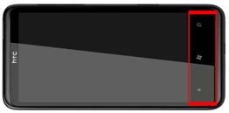
Fig. 1 The white arrow shows the area unintentionally touched by the users while scrolling the pictures

- Results
International Science Index, Humanities and Social Sciences Vol:6, No:5, 2012 waset.org/Publication/12340
Though the task seems very easy and simple but the main idea behind performing this task was to see how many users accidently touches the unwanted area on mobile main buttons. It was very amazing to see that 12 of the participants touched the wrong or unintentional area while scrolling the pictures from right to left.
This mistake is because of too much sensitivity of the mobile screen and buttons and not defining the proper boundary for the buttons. While scrolling, the users will accidently touch the area between the buttons.

- Solution
Two different solutions were proposed:
- Either provides proper boundaries to the buttons (fig
2) and any region outside those boundaries when clicked should not perform any task.
- Provide a lock button so the users can lock the main three buttons and avoid any accidental pressing of the buttons and unlock it whenever it is required (see fig 2).
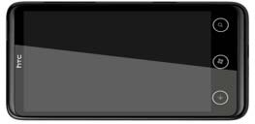
Fig. 2 Shows the solution to the problem. All buttons have a proper boundary defined and shows a circular region around every button

- The soft and hard button task
Users were asked to check whether the soft button is more effective or the hard button. For the soft buttons the user were asked to use the three provided buttons at the bottom of the mobile. While users were using the mobile, the force feedback was on for the soft buttons and vibration would feel every time they would press the button. Also the users were asked to take a picture of a person in a relatively low light room by using the provided hard button of the mobile

- Results and solution
It was noticed that 13 out of 17 participants preferred the soft buttons while 4 preferred the solid button. However it is also noticeable that while performing the task of taking pictures in low light made the picture blur as using hard button on a slim mobile would make the mobile move while pressing the hard button. Total of 14 participants made the picture blur while using the hard button. In such case using a soft button is more preferable. In suggestions people preferred to have a soft button for a camera and one hard button in the menu button as that would provide a proper feedback. About the vibration in soft buttons, people suggested that the vibration was meaningless as all kinds of actions had the same vibrations feedback. About 9 participant thought vibration has no use at all, 5 says they can’t say anything about it while 3 thought of
vibration to be very affective. This means there is need for defining separate vibration modes for all actions.

- Mobile holding task
This task included several tasks within one. Users were asked to type message while holding the mobile vertically. Then again type the message while holding the mobile horizontally. Similarly in both types of message composing tasks, users were ask to type a message with the key press sound on and key press sound off.

- Results and solution
Almost all of the participants took more than usual time to type the message. One reason could be that most of the participants were using a touch screen mobile for the first time therefore they could not use the typing keyboard properly. Total of 15 users found typing vertically more difficult than horizontally as there was not enough space in mobile to hold it on properly. Though using mobile horizontally was more fun and ease in use but 13 participants accidentally pressed the unwanted buttons on the main menu bar while holding it horizontally. The red area defined in figure 1 was mostly touched un intentionally while using mobile.
The provided solution for this task was to remodel some of the extra features of the mobile. Though being slim is a good feature but at the same time its hard to handle a mobile. Following images shows the new remodelled flips for the mobile for better grip and handling.
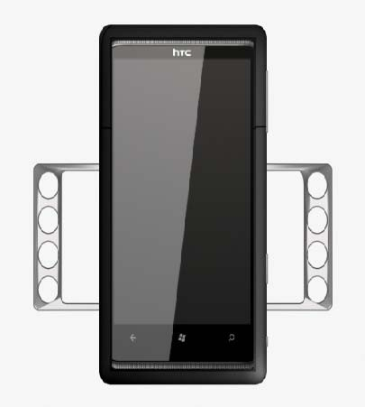
Fig 3 Shows a vertical position of mobile with flips on both sides for better grip on the mobile

International Science Index, Humanities and Social Sciences Vol:6, No:5, 2012 waset.org/Publication/12340

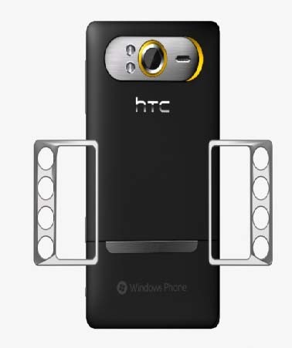
Fig. 4 Shows the back side of the mobile with flips outward

The provided flips for grip not only provides a better handling but also to be used as a stand for making the mobile sit in front of the user. See the following image for better understanding.
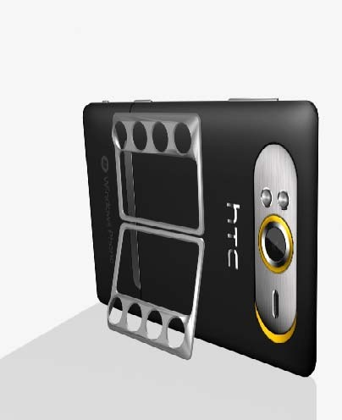
Fig. 5 Shows the use of flips as a mobile stand

- THE NEW INTERFACE DESIGN
So far we have seen changes in the physical design of the mobile but there is also need for a change in the software interface as well. The usual mobiles have either tab view interface or the scroll based interface. Both have their uses in their own ways. We suggest a new interface design called “The Spider Web design”. The design was implemented in QT application. QT is a library used for designing interfaces. It is owned by NOKIA and the basic version has been made free for the developers. We integrated QT with visual basic and designed this interface. Though the interface has not been

implemented in any mobile yet but to give a rough idea of how this interface would work, we have implemented it in QT for use in Windows operating system.
The figure 6 shows our designed interface. The interface works on clicking mechanism. It starts with a home button on the screen and which is the only button. When the user clicks the home button, it gets expanded showing other applications inside the home such as Games, Maps, Music and Apps etc. If a user wants to go back to the previous menu, he can simply click on the last pressed button again to move to the previous menu. After clicking the home button if the user wants to play games and if he clicks on games that would show games inside the games button. This menu type does not involve any scrolling or tab, just clicking and clicking is faster than scroll.
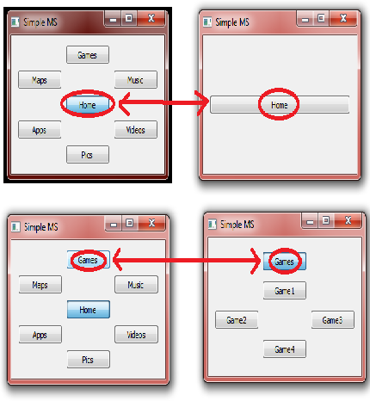
Fig. 6 Shows different parts of Spider web interface

- CONCLUSION
This paper aims towards making the physical and software interface of the latest smart phones very affective and easy to use. After considering the research work done on the papers and the flaws discovered using HTC HD7, we proposed solutions to those problems and solutions advised after considering the feedback of the 17 participants who participated in the survey. The changes suggested by us involved a new interface design which was made in QT development kit.

International Science Index, Humanities and Social Sciences Vol:6, No:5, 2012 waset.org/Publication/12340

REFERENCES
- Cyr, D., Head, M. and Ivanov, A. (2006). Design aesthetics leading to m-loyalty in mobile commerce. Information & Management, 43(8), 950- 963.
- F. Balagtas-Fernandez, J. Forrai, and H. Hussmann, “Evaluation of user interface design and input methods for applications on mobile touch screen devices,” in Proceedings of the 12th IFIP TC13 International Conference on Human-Computer Interaction (INTERACT), 2009.
- Koji Yatani, and Khai N. Truong. "SemFeel: A User Interface with Semantic Tactile Feedback for Mobile Touch-screen Devices" In Proceedings of the ACM Symposium on User Interface Software and Technology (UIST 2009), pp. 111 -- 120, October 2009.
- G. Bruner, A. Kumar, Explaining consumer acceptance of handheld Internet devices, Journal of Business Research 58, 2003, pp. 115–120.
- M. Jones, G. Marsden, N. Mohd-Nasir, K. Boone, G. Buchanan, Improving web interaction on small displays (accessed on February 4, 2005 at: http://www8.org/w8-papers/1b- multimedia/improving/improving.html).
- T. Rist, P. Brandmeier, Customizing graphics for tiny displays of mobile devices, in: M.D. Dunlop, S.A. Brewster (Eds.), in: Proceedings of Mobile HCI 2001: Third International Workshop on Human Computer Interaction with Mobile Devices, Lille, France, September, 2001.
- S. Brewster, P. Cryer, Maximising screen-space on mobile computing devices, in: Proceedings of the Conference on Human Factors in Computing Systems (CHI’99), Pittsburgh, Pennsylvania, 1999.
- L.E. Holmquist, Will baby faces ever grow up? in: H.-J. Bullinger, J. Ziegler (Eds.), Ergonomics and User Interfaces, HCI International Conference Proceedings 1, Munich, Germany, August 22–26, 1999, pp. 706–709.
- E. Kaasinen, M. Aaltonen, J. Kolari, S. Melakoski, T. Laakko, Two approaches to bringing Internet services to WAP devices, computer networks, The International Journal of Computer and Telecommunications Networking 33 (1–6), 2000.

